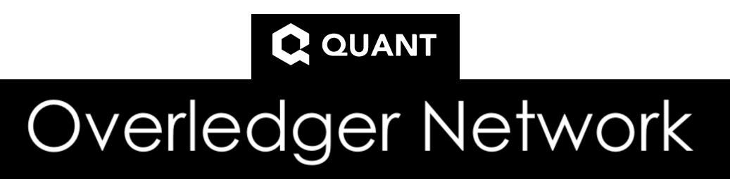

**Unofficial Community Overledger Network - Public Cloud Setup**

**Test Network**

**v1.0 – 27/08/2020**

**Location:** [**https://1drv.ms/w/s!AsXBygErz6PagpIHTdPIGSIOVqDo1g?e=Jz6Ju2**](https://1drv.ms/w/s!AsXBygErz6PagpIHTdPIGSIOVqDo1g?e=Jz6Ju2)

**Written by:** @CryptoFielder (Twitter and Telegram handle) - Quant holder and community member since 2019

**Important**: It is a requirement that the Gateway is upgraded once a week to ensure the latest code is deployed, if not it is likely your gateway will fail to connect. Please see section ‘Upgrading the Quant Gateway’ on how to do this.

***Disclaimer***: This is an unofficial guide and is not endorsed by Quant and is community written. The guide is written to the authors best knowledge and accepts no liability for any damage or cost incurred by following it.

Contents

1) Pre-requisites 3

Quant Network registration 3

Ethereum Wallet 3

Ethereum Wallet – Test ETH 4

SSH/Remote Terminal 5

Windows 5

MAC 5

Digital Ocean Account 5

Securing your Digital Ocean account further 5

2) Securing your Droplet/Virtual Machine further by enabling a Firewall 8

3) Connecting to your Cloud virtual machine 9

4) Installing Docker on your Virtual Machine 11

5) Adding wallets into the Overledger Dashboard 11

6) Installing the Mongo DB and Overledger Gateway image (including setup) on your Virtual Machine 13

7) Approve the treasury smart contract 15

8) Troubleshooting 17

Java exception errors or peers not connecting 17

Mock requests to confirm the gateway is working 18

9) Appendices 19

Overledger Network Videos 19

Developer Portal Registration, Running Gateways and Dashboard walkthrough 19

Upgrading the Quant Gateway 19

Version History 20

# Pre-requisites

## Quant Network registration

BPI Key – From signing up to : <https://developer.quant.network/login> you will need this eventually but you can complete sections 1 – 4 and part of 6 without it so the virtual machine is 95% setup and once you have been granted registration you can continue.

## Ethereum Wallet

For the gateway to interact with the treasury there is a requirement for 2 Ethereum addresses:

1. QNT Wallet – The stakeholder’s address that will hold any QNT
2. Operator – The stakeholder’s address that can call function on the treasury smart contract

For the test quant network these addresses will be used on the Ropsten test net and to ensure there is no conflict or mistakes it is recommended these addresses are only ever used on the Ethereum test net.

For this guide I have chosen to use a MetaMask via a desktop browser as it hooks straight into your web browser such as ‘Chrome, Firefox and Brave’ and if you choose IOS and Android. It also allows you to create multiple accounts in the same wallet which is perfect for the two separate ones needed here.

1. Install from <https://metamask.io/> into your desktop browser choice
2. Click on the MetaMask icon on the top right of your browser where the extensions are:



1. Create a password, I would recommend a strong randomised password and record it safely, you will need this to unlock the MetaMask wallet each time the browser is opened
2. Read and accept the terms of use
3. Record the Secret Backup Phrase carefully so you can restore the wallet if required:

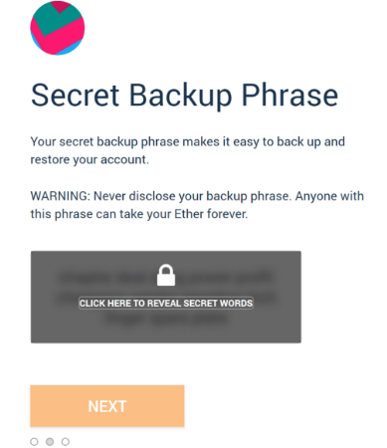

1. Proceed and confirm the secret phrase back into the setup process which makes sure you recorded it properly and complete the setup
2. This guide assumes that the main wallet created is for live use, therefore 2 additional wallets will be created. Go back into the MetaMask Wallet via the extension

and select ‘Create Account’

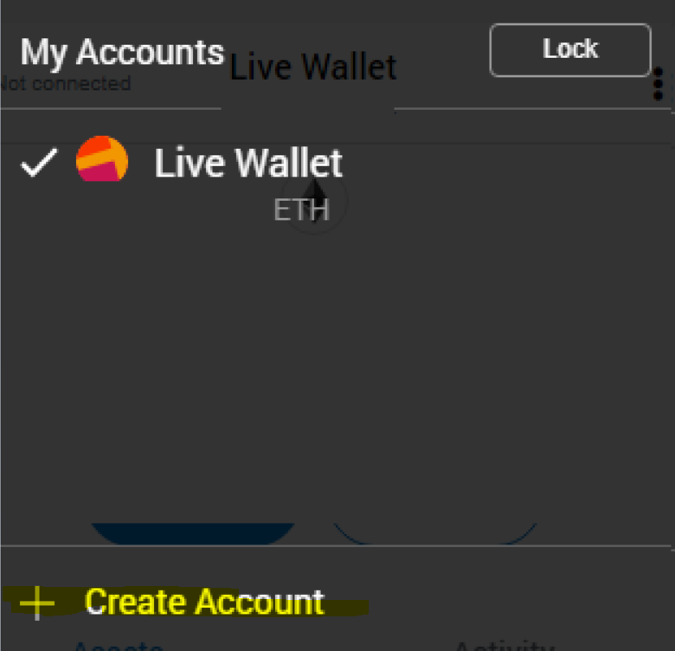

1. Give the account a name such as ‘Quant Operator Test Network’, once created it will automatically open that account and you can view the address at the top of the window
2. Repeat this for another account which could be named ‘Quant Test Network’ for example or a more generic name if using for other tokens.

## Ethereum Wallet – Test ETH

Just like the live wallet in interact with the Ethereum network your going to need GAS and therefore ETH. To acquire test ETH you will need to connect to a ‘Faucet’ as we have used MetaMask above I have selected their own at the address <https://faucet.metamask.io/>.

1. Unlock your MetaMask wallet and select the Test Wallet where the test QNT will be sent to and open <https://faucet.metamask.io/> in the web browser
2. Select ‘request 1 ether from faucet’ and the approve the connector to your test wallet when MetaMask requests it:

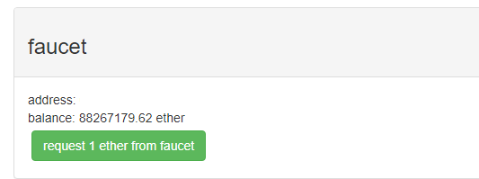

1. If the 1 ETH does not appear under the Activity, then click the ‘request 1 ether from faucet’ again until you see:

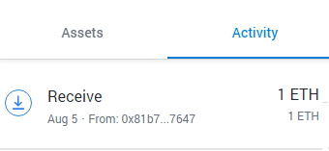

## SSH/Remote Terminal

### Windows

Putty - <https://www.chiark.greenend.org.uk/~sgtatham/putty/latest.html>

Download the relevant x86 or x64 MSI binary and install using the default options. This is used to create the session connection to your Ubuntu virtual machine. You can use the console via the Digital Ocean cloud provider, but I found it laggy and pasting code across was inaccurate.

### MAC

Terminal

Use the built in ‘terminal’ application and connect using:

*SSH root@*’Insert IPv4 Address of your Droplet VM’

e.g *SSH root@86.254.6.98*

## Digital Ocean Account

I have selected Digital Ocean as cloud provider and for this guide due to their stringent security policies and competitive pricing compared to other cloud providers.

* Sign up using the registration link code here : <https://m.do.co/c/c5ad766cfe39> - **Disclosure** : You get a $100 to use for a period of time apparently and I get $25 for the referral
* PayPal or Credit Card – For cloud provider payment
* Google Authenticator for 2FA as part of Multi Factor Authentication login

### Securing your Digital Ocean account further

1. Further secure your Digital Ocean account by enabling 2FA on it. To do so select from the left-hand pane ‘Settings > Two-factor authentication settings’ under ‘sign in method’. Follow the on-screen prompts for example use Google Authenticator.

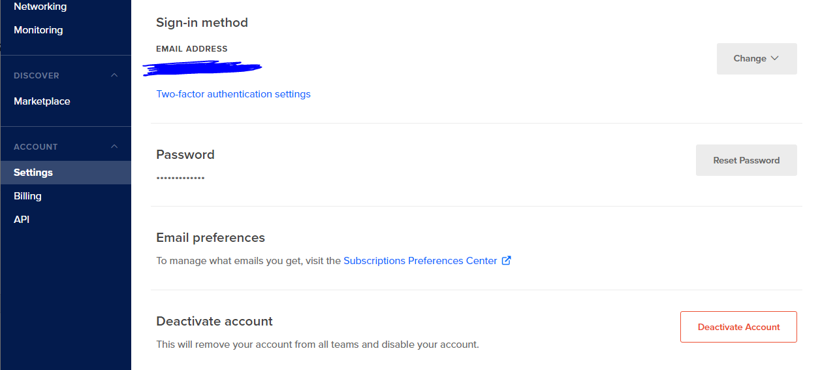

Creating your first Droplet virtual machine

**Note**: Any settings not called/references are to be left as default

1. First select *‘Droplets’* from the left-hand pane then select
2. Then select *‘Create’* from the green box on the top right
3. Select if not already *‘Ubuntu’* > ‘Basic’ > ‘*$5 /mo’* – The rule I always use is start small and ramp up later to save cost, 1vCPU and 1GB RAM will be sufficient (I personally went with 2 vCPU and 2GB RAM as I am doing other activities on it) to get this all setup to begin with and I’ll provide a set of steps later in the guide here X on how to scale up the virtual machine.

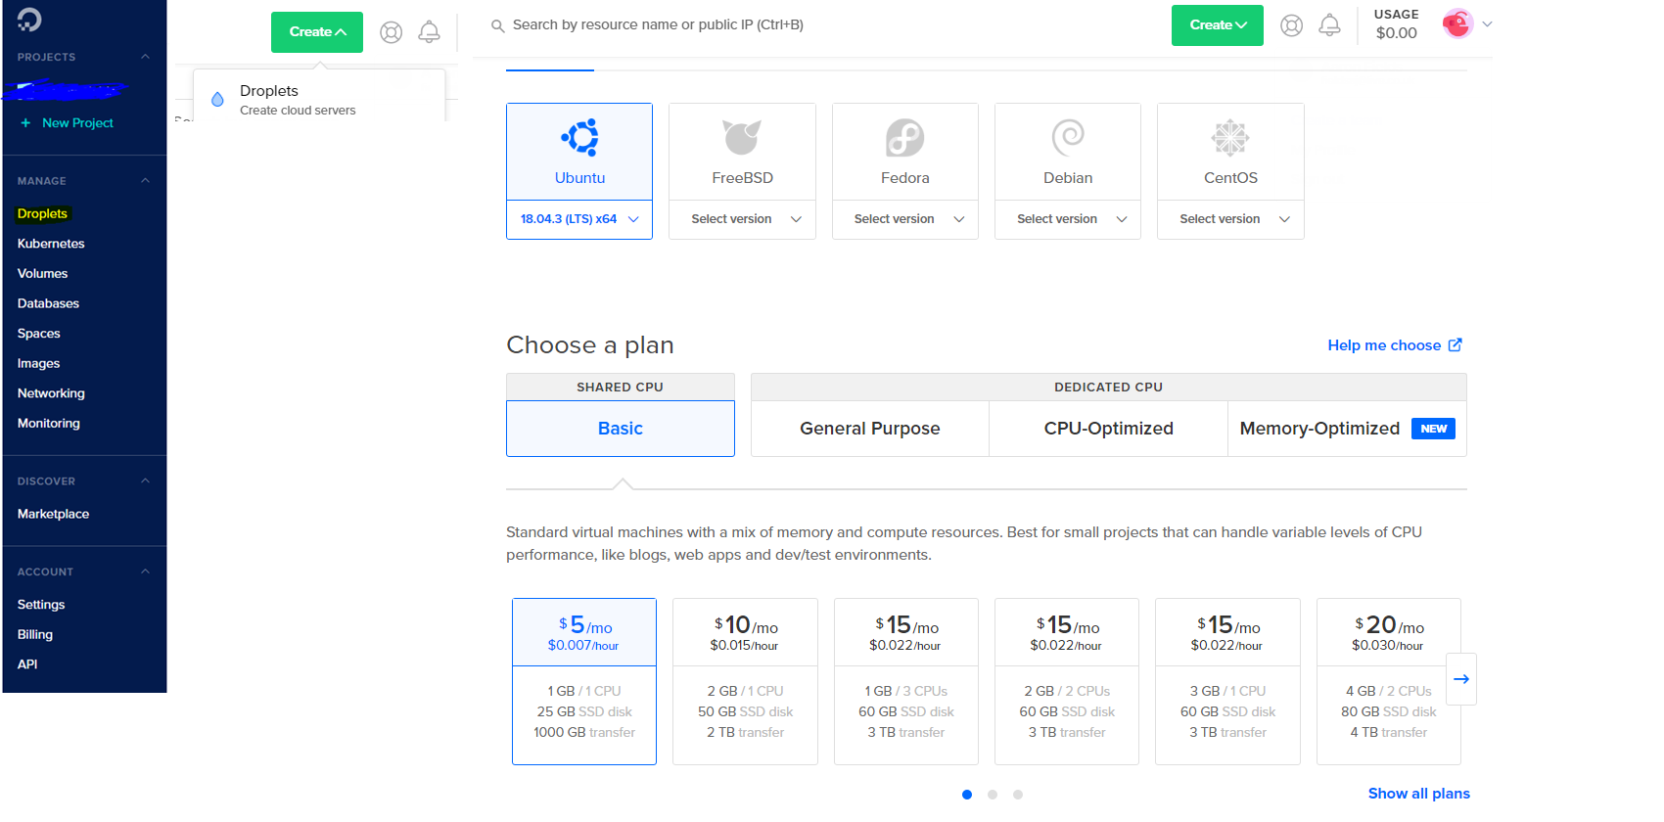

1. For this guide we are setting up a single virtual machine so normally I would choose the one that is the cheapest and complies to local regulations, but at present it appears they all cost the same. Personally, as I am in the UK, I have chosen London, so the Putty connection has the lowest latency.

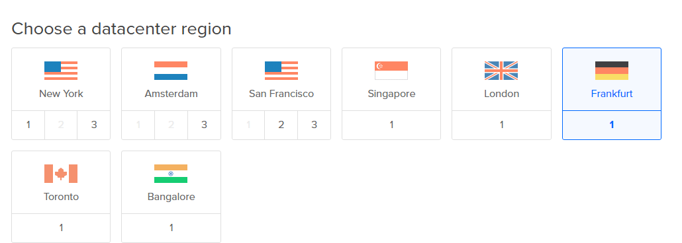

1. Setup a root password following the password complexity requirements set out when you click the box

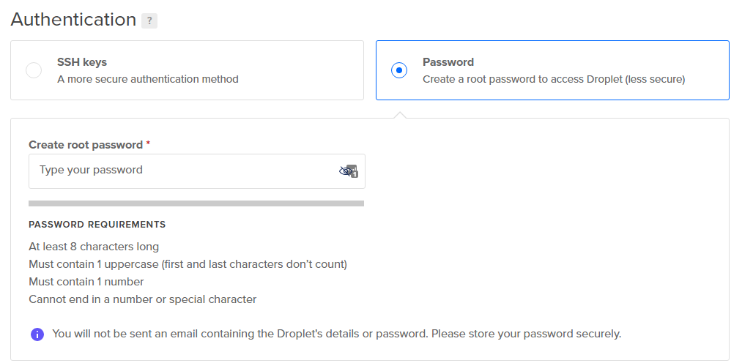

1. Optional - Choose a name for your virtual machine within the ‘Hostname’ field

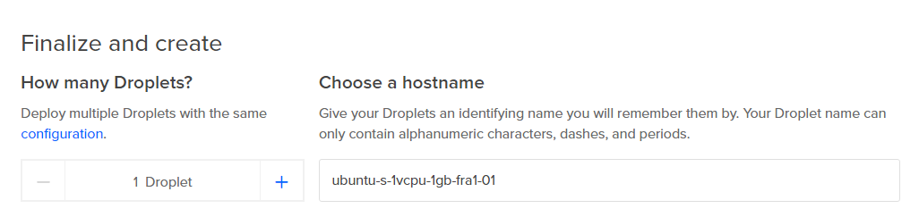

1. Select ‘Create Droplet’ at the bottom of the page

# Securing your Droplet/Virtual Machine further by enabling a Firewall

The guide assumes you are familiar with what a Firewall does but if not here is Digital Oceans page for an explanation and further more detailed guides : <https://www.digitalocean.com/docs/networking/firewalls/?utm_medium=email&utm_source=local&utm_campaign=CloudFirewallsResource>

1. From the left-hand pane select ‘Networking’ > ‘Firewalls’ > ‘Create Firewall’

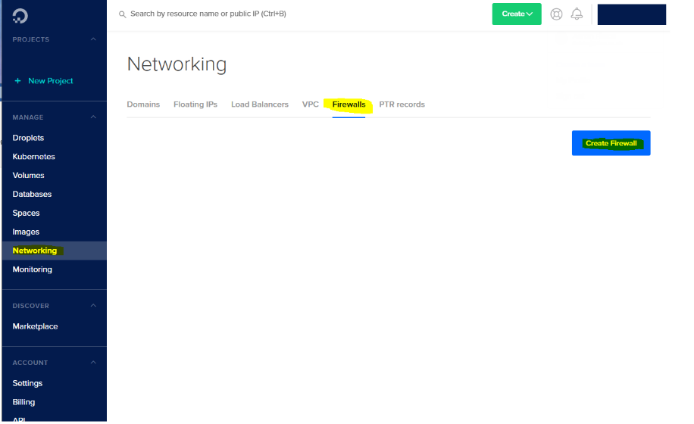

1. Within the *‘Name’* box enter the name of the Firewall ruleset, for example *QuantGatewayRuleset* and then apply the default set of rules to the VM you created by searching for it in the bottom box labelled *‘Apply to Droplets’* and finally clicking *‘Create Firewall’*

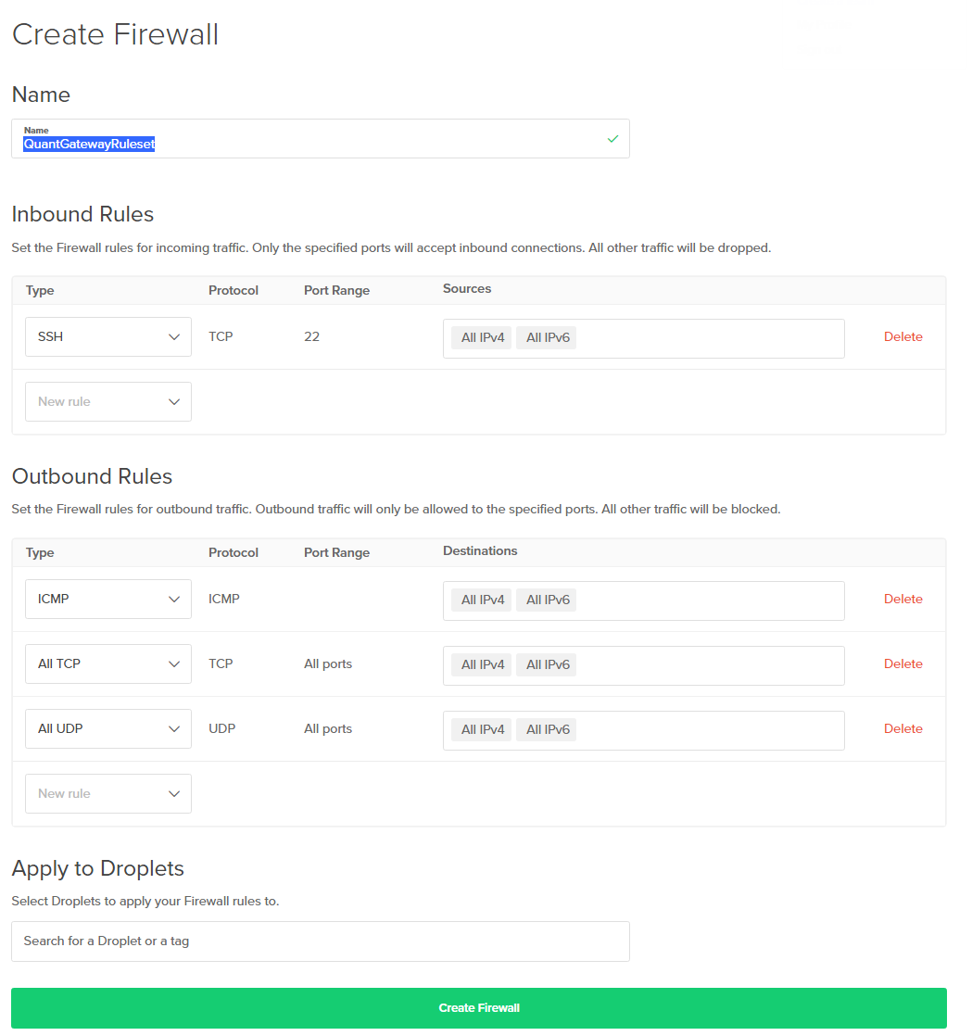

# Connecting to your Cloud virtual machine

**Note** : If using MAC you can use the built in Terminal application and use the commands:

*SSH root@*’Insert IPv4 Address of your Droplet VM’

e.g *SSH root@86.254.6.98*

1. Within Windows Open Putty which was installed as part of the pre-requisites and enter the IPv4 address assigned to your virtual machine droplet into the ‘*Host Name (or IP address)*’ e.g. *212.324.244.5* (this is a dummy address) and enter *Ubuntu Droplet* for example as a name to save the session connection for next time followed by *‘Save’*

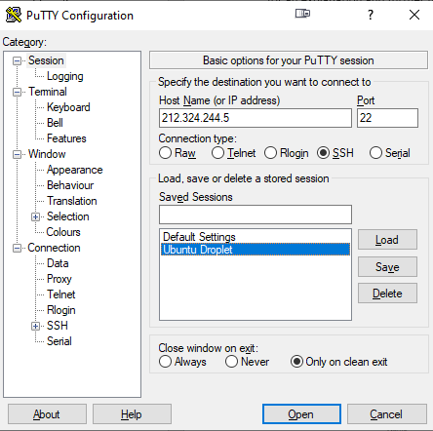

1. Select the saved session from the list and click ‘*Load > Open*’ or *Double Click* with the mouse. Note: If you get a message asking you to trust the host click *‘Yes’*

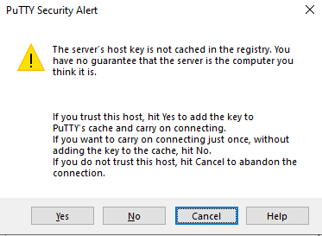

1. Enter *‘root’* followed by *‘Enter’* on the keyboard

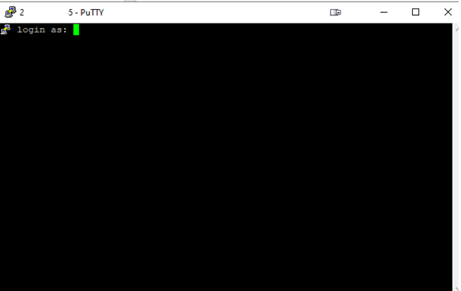

1. Enter the password you set when creating the droplet virtual machine within the Digital Ocean portal and pressing ‘enter’ on your keyboard. Note : It will not show you entering anything but you are, you can also copy like you would any text and paste it in by ‘*right clicking’* you mouse into the terminal window followed by ‘*Enter’* on your keyboard.

# Installing Docker on your Virtual Machine

Tip 1: You can also copy like you would any text and paste it in by ‘*right clicking’* you mouse into the terminal window followed by ‘*Enter’* on your keyboard. But where you can I recommend you type it in, so you get used to the command line structure.

Tip 2: Unix is case-sensitive in most cases so bear that in mind when entering commands

1. First, we start by install Docker. From the Putty session being logged in type the following command ‘*snap install docker*’ followed by ‘enter’ on your keyboard. The output will look like the below:

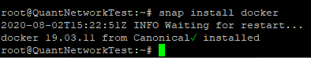

# Adding wallets into the Overledger Dashboard

**Note:** It is recommended that you add in the wallets prior to the next steps so when the Gateway connection is established the wallets are available. But you can continue and come back to this step if your registration is not yet approved and you want to have the gateway ready to configure.

1. Open the Overledger Dashboard and left click the Wallet icon highlighted in yellow bow and select ‘manage’

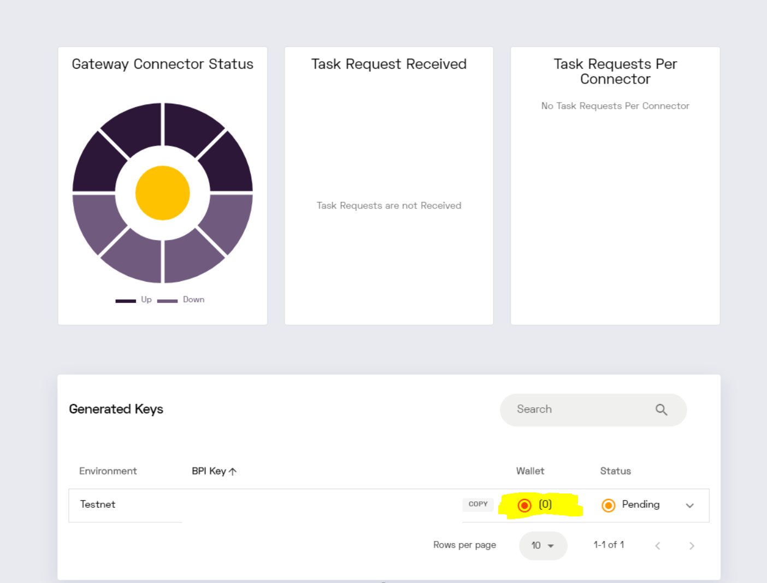

1. Using the drop down box within ‘Type’ and ‘add’ enter each of the setup wallets addresses created either within this guide under the 1)Pre-Requisites section ‘Ethereum Wallet’ or two that you own:

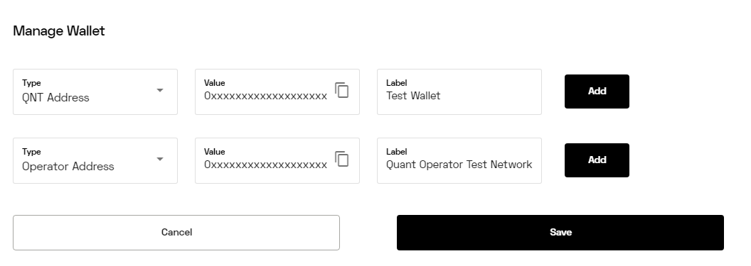

1. The dashboard should now show *Wallet* as *‘(2)’* with the icon green and the *Status* *‘Enabled’*

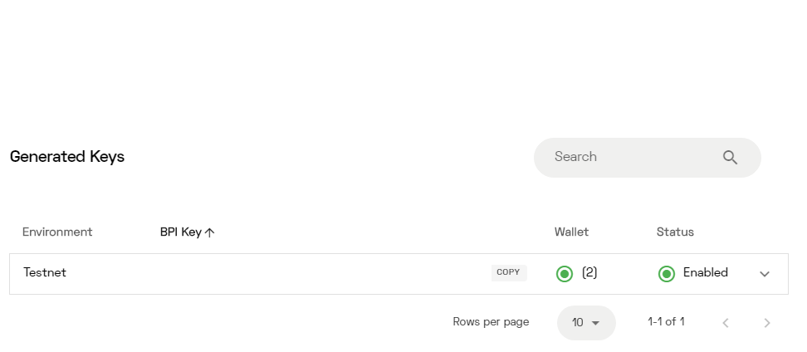

# Installing the Mongo DB and Overledger Gateway image (including setup) on your Virtual Machine

Create a docker instance for the Overledger network which will contain a MongoDB and the gateway.

1. From the Putty session being logged in type the following command ‘*docker network create ovl-net’* followed by ‘enter’ on your keyboard. The output will look like the below:



1. Install the MongoDB binaries into the instance. From the Putty session being logged in type the following command ‘*docker run -d --name ovl-mongo --network ovl-net -p 27017:27017 mongo:latest’* followed by ‘enter’ on your keyboard. The output will look like the below

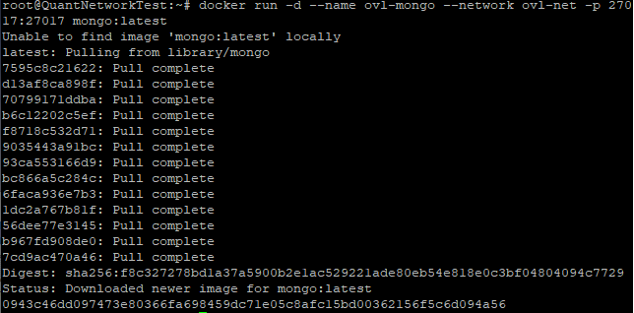

1. Install the latest Docker image for the Overledger network within the setup instance created. From the Putty session being logged in type the following command followed by ‘enter’ on your keyboard:

**Reminder:**

As stated in section 6) Adding wallets into your Overledger Dashboard you will need your registration approved your BPI key before your can continue the next set of steps.

**Important**:

1. Replace after the = ‘-e GATEWAY_ID="’ with your BPI key obtained from the Developer Quant Network portal – **NEVER** give this out!
2. Replace after the = ‘-e GATEWAY_HOST ="’ with your IPv4 address obtained from your Droplet virtual machine in the Digital Ocean console or the same one used to connect the Putty session with.

docker run -dit \

--name overledger-network-gateway \

--network ovl-net \

-p 8080:8080 -p 11337:11337 \

-e GATEWAY_ID="your-bpi-key" \

-e GATEWAY_HOST="your-public-IP" \

-e MONGO_DB_HOST="ovl-mongo" \

quantnetwork/overledger-network-gateway:latest

1. Once the command has been entered you will receive a confirmation ID back e.g. *fg5a324552aasfdfsd093r09jf09rad8ua90duausfasd09f8sadfjasf098asf090af2*
2. To view the status of the Gateway, enter the command *‘docker logs -f overledger-network-gateway’* this provide a constant stream of the log file. The Gateway will start up with a random number of connectors between C1 and C10. A good example of a working gateway will look the below showing the ‘peers connected’ string and within that ‘*Connector (id=cX) , status =true’*:



&



The information in scrubbed out in blue shows a peer ID connected with an internet routable IP address.

1. Optional – If you have entered your wallet information on the Quant Dashboard after starting the gateway you may not have restart the docker container, to do this please see troubleshooting section Java exception errors or peers not connecting

**Note:** You can press *ctrl+c* to exit the log and return to the command line

# Approve the treasury smart contract

1. Within your MetaMask wallet browser unsure it is unlocked, and you have selected the test QNT account and select the *‘Ropsten Test Network’* by clicking the top part of the MetaMask Wallet:

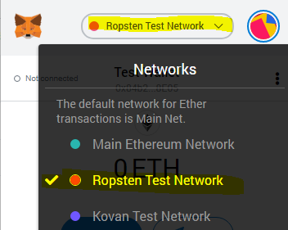

1. Navigate in the browser to : <https://ropsten.etherscan.io/address/0x19bc592a0e1bab3affb1a8746d8454743ee6e838>

You must see the following contract ID: 0x19Bc592A0E1BAb3AFFB1A8746D8454743EE6E838

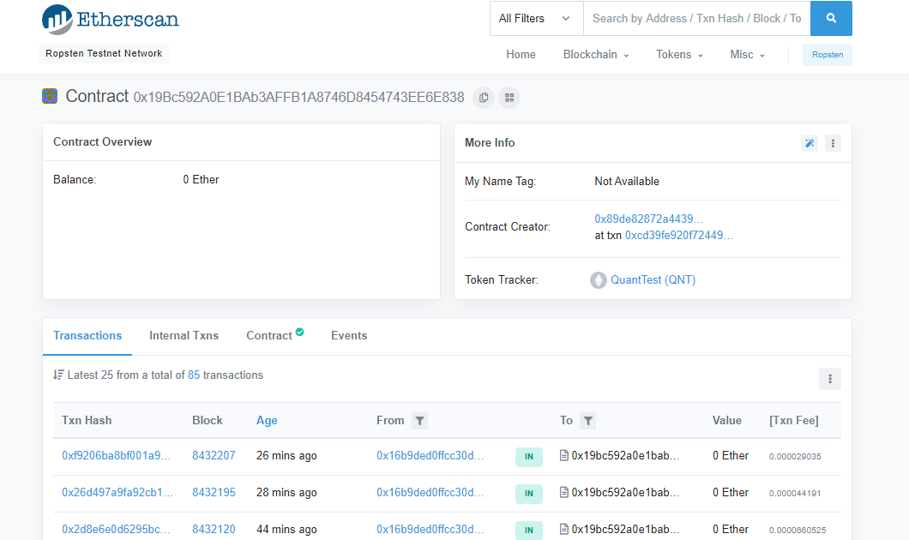

1. Select *‘Contract’* followed by selecting ‘Write Contract’ and then *‘Connect to Web3’*

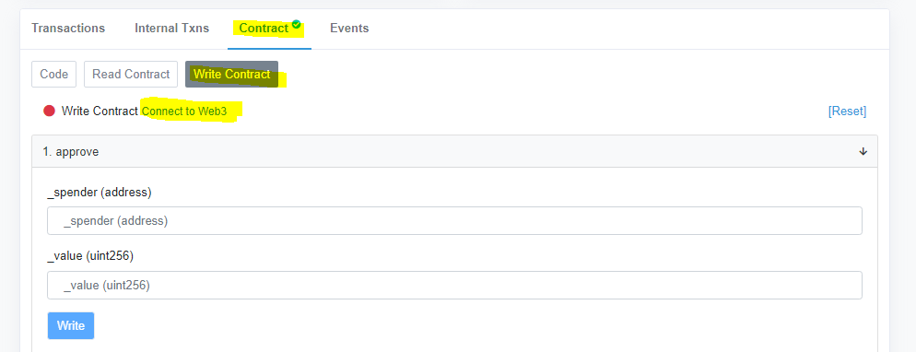

1. A MetaMask notification will then appear where if you have already selected the relevant account it should be selected, double check it is your test account and name followed by *‘Next’ and ‘Connect’*

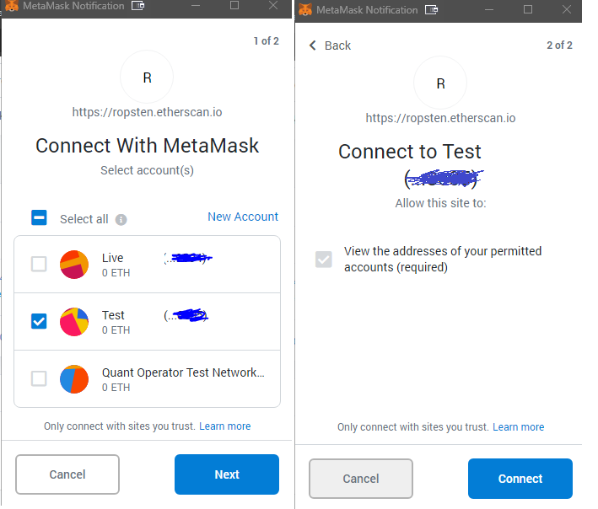

1. You can confirm it is connected by going back into your MetaMask wallet and ensuring the account is marked as ‘connected’ with a green light

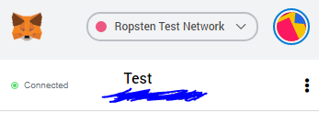

**Note**: Before continuing please ensure your have test ETH in your Test account, see section Ethereum Wallet – Test ETH on how to obtain

1. To approve the treasury smart contract taking the recommended starting amount as per the Quant video of up to 115 test QNT perform the write contract approve function. On ‘*1.Approve’* fields add in:
2. _spender (address) = 0x4a42aa05fb7cd58e9e388c82ec11b811bdf5ada7 – Ropsten treasury factory smart contract
3. _value (uint256) = 115000000000000000000 (18 decimal places = 115)

Click ‘Write’ followed by ‘Confirm’ in MetaMask

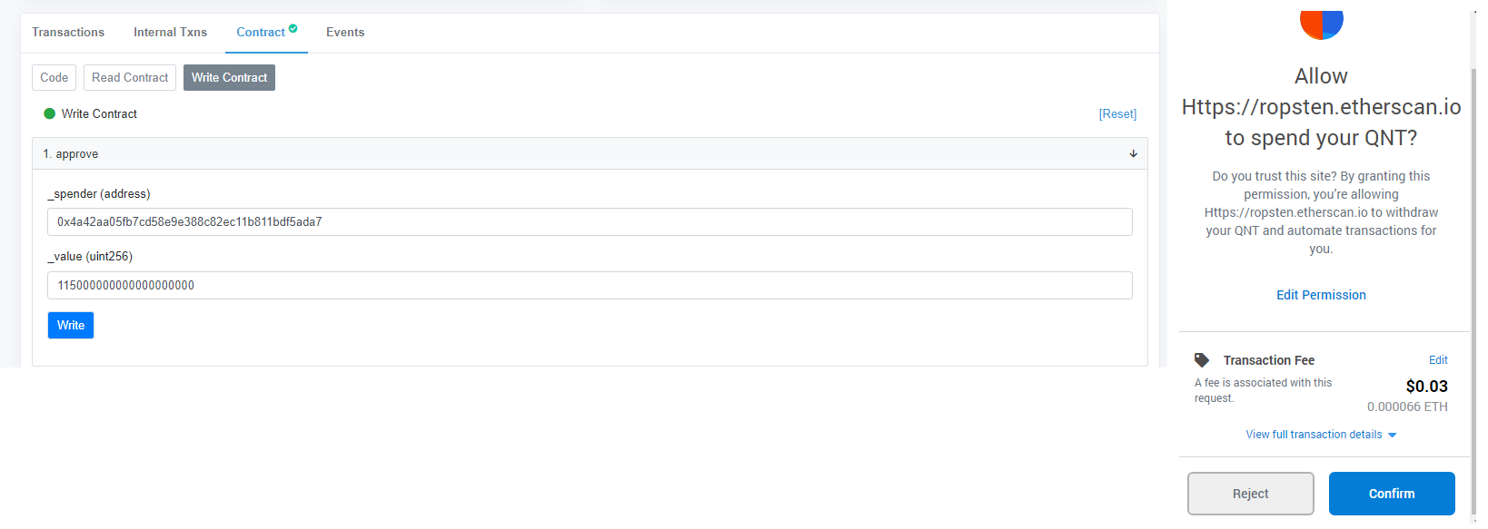

1. To check if it was successful. Navigate to ‘Read Contract’ and enter the following:

Owner (address) = 0xcasd098r5jda0ik22x1 (dummy example) - Your test account that you approved in Step 6

_spender (address) = 0x4a42aa05fb7cd58e9e388c82ec11b811bdf5ada7 – Ropsten treasury factory smart contract

Click ‘Query’

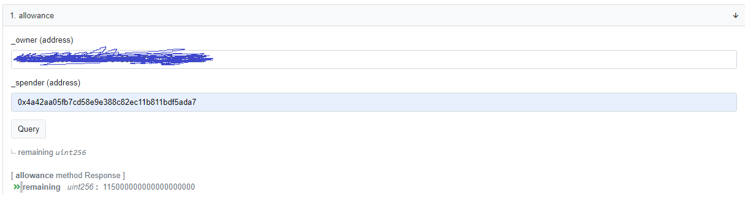

The output will state the allowance remaining is ‘115000000000000000000’ if the Smart Contract is not live yet.

# Troubleshooting

## Java exception errors or peers not connecting

If the Gateway is not working correctly via error messages in the docker container log file you can restart the Quant Network image by:

1) Command 'docker ps -a' - List all docker containers and the status of them

2) Note the container ID of the 'quantnetwork/overledger-network-gateway:latest ' e.g. ab134drtty

3) Command 'docker stop ab134drtty' - Same container ID above to it gracefully terminates the process

4) Command - 'docker start ab134drtty' - Start the gateway container again

5)View the docker container logs of the gateway specifically by using command 'docker logs -f overledger-network-gateway’

**Note**: It can take circa 5-10 minutes before a peer connection occurs and the logs may not update during this time

## Mock requests to confirm the gateway is working

To submit mocks requests to the Quant gateway to confirm it is working:

1) Command – ‘docker logs -f overledger-network-gateway’

2) The log will show the docker gateway log where it starts up with a random number of connectors between C1 and C10. To run the mock request, you need to find a ‘peers connected’ string and within that ‘Connector (id=cX) , status =true’ and note that down

3) Using the ID you noted above use the command 'curl -H "Content-Type: application/json" -X POST -d '{"connectorId":"CX","task":"Send transaction"}' http://localhost:8080/tasks' - Where 'X' within 'CX' equals the connector number

4) You will then get if working a response like {"peerId":"xxxxxxxxxxxxxxxxxxxxx","connectorId":"C5","status":"Success","message":"Successfully completed the task."}snip



# Appendices

## Overledger Network Videos

|  |  |
| --- | --- |
| **Description** | **Link** |
| Developer Portal Registration, Running Gateways and Dashboard walkthrough | <https://www.youtube.com/watch?v=gObSCJqmloY> |
| Running Gateways | <https://www.youtube.com/watch?v=HHLRzCKI7yY> |
| Running TestQNT Payment Channels with Treasury | <https://www.youtube.com/watch?v=Uy6eKO1rHWc&feature=youtu.be> |
| Understanding Dashboard Statistics | <https://www.youtube.com/watch?v=OLOzeAw_hSU> |

## Upgrading the Quant Gateway

It is a requirement this is completed once a week to ensure the latest code is deployed . To complete the docker container running the Quant Gateway will need to be stopped and removed, the MongoDB will stay as is.

1. List all running containers, as well as containers that have been shut down by running the command line *‘docker ps -a’ t*hen, take note of the ID of the Overledger Network Gateway container:



1. Within the command line type ‘docker stop Insert gateway-container-id-here’ e.g. docker stop ab6f852facc1’ to stop it
2. Within the command line type ‘docker rm gateway-container-id-here’ e.g. docker rm ab6f852facc1’ to remove it
3. Within the command line type ‘docker rmi quantnetwork/overledger-network-gateway’ to remove the old gateway image
4. Within the command line type ‘docker pull quantnetwork/overledger-network-gateway’ for the latest Quant Network gateway image to be pulled
5. Within the command line type the following command followed by ‘enter’ on your keyboard:

**Important:**

1. Replace after the = ‘-e GATEWAY_ID="’ with your BPI key obtained from the Developer Quant Network portal – **NEVER** give this out!
2. Replace after the = ‘-e GATEWAY_HOST ="’ with your IPv4 address obtained from your Droplet virtual machine in the Digital Ocean console or the same one used to connect the Putty session with.

docker run -dit \

--name overledger-network-gateway \

--network ovl-net \

-p 8080:8080 -p 11337:11337 \

-e GATEWAY_ID="your-bpi-key" \

-e GATEWAY_HOST="your-public-IP" \

-e MONGO_DB_HOST="ovl-mongo" \

quantnetwork/overledger-network-gateway:latest

1. Once the command has been entered you will receive a confirmation ID back e.g. *fg5a324552aasfdfsd093r09jf09rad8ua90duausfasd09f8sadfjasf098asf090af2*
2. To view the status of the Gateway, enter the command *‘docker logs -f overledger-network-gateway’* this provide a constant stream of the log file. The Gateway will start up with a random number of connectors between C1 and C10. A good example of a working gateway will look the below showing the ‘peers connected’ string and within that ‘*Connector (id=cX) , status =true’*:



&



The information in scrubbed out in blue shows a peer ID connected with an internet routable IP address.

**Note:** You can press *ctrl+c* to exit the log and return to the command line

## Version History

|  |  |  |  |
| --- | --- | --- | --- |
| **Version Number** | **Date** | **Author** | **Comments** |
| 0.1 | 02/08/2020 | CryptoFielder | Pre-Reqs, Public Cloud setup via Digital Ocean (including sign up, security & creation of a VM) & Connecting to the virtual machine |
| 0.2 | 02/08/2020 | CryptoFielder | *Installing Docker on your Virtual Machine and setup of the Quant Network Gateway.  *Future updates are pending Quant Support registration completion. |
| 0.3 | 04/08/2020 | CryptoFielder | *Page formatting  *Added in a pre-req section for MetaMask wallet creation with additional accounts for the 2 Quant address requirement  *Added a new section on where to input the Ethereum wallets into the dashboard  *Completed the setup of the Quant Gateway end to end with section 7 completed  *Added in links and descriptions of the Quant team videos into the appendix |
| 0.4 | 04/08/2020 | CryptoFielder | *Troubleshooting section added in  *Added in an example Peer connection into the Section 7  *Added in a section to approve the Treasure Smart Contract |
| 0.5 | 05/08/2020 | CryptoFielder | *Pre-Req - Ethereum Wallet – Test ETH : Test Faucet section to get ETH on your Ropsten Test Network account  *Approve the treasury smart contract - Completed in full for preapproving the smart contract ready for when we receive the test QNT circa Thursday, 06/08/2020 |
| 0.6 | 06/08/2020 | CryptoFielder | *Added in Upgrading the Quant Gateway into the appendix |
| 0.7 | 12/08/2020 | CryptoFielder | *Added in MAC SSH/Terminal connection and separated Windows putty out |
| 0.8 | 24/08/2020 | CryptoFielder | *Made it clear that an upgrade to the gateway needs to occur once a week on the front page  *Added additional step 4) to the upgrade process of the Quant Gateway Upgrade to remove the old image from docker entirely |
| 1.0 | 27/08/2020 | CryptoFielder | *Made fully live based on positive feedback from the community  *Updated various sections to align with an upload to the Quant team for community publish |